Making music with MicroPython and the BBC micro:bit
With the new built-in music library in Micro Python, it is now possible to play music on your BBC micro:bit, provided that you connect a speaker to your device. Use crocodile clips to attach pin 0 and GND to the positive and negative inputs on your speaker.
Before we start, we must import the music library. The music library contains the methods used to make and control sound. Use the import music command to load the music library.
Once you have imported the music library, it is possible to programme your device to play notes (or tones).
Playing musical notes
In Micro Python, we use lists to play a sequence of notes.
Here is the code for the opening bars of ‘Frere Jaques’:
tune = ["C4:4", "D4:4", "E4:4", "C4:4", "C4:4", "D4:4", "E4:4",
"C4:4", "E4:4", "F4:4", "G4:8", "E4:4", "F4:4", "G4:8"]
Each note is expressed as a string of characters like this:
“C4:4”
Where C = note, 4 = octave and :4 = duration (ticks).
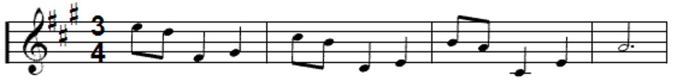
Once we have created our sequence (list) of notes, we can instruct the micro:bit to play our melody using the music.play command. Your code should look like this:
import music
tune = ["C4:4", "D4:4", "E4:4", "C4:4", "C4:4", "D4:4", "E4:4",
"C4:4","E4:4", "F4:4", "G4:8", "E4:4", "F4:4", "G4:8"]
music.play(tune)
Transcribing songs from sheet music
If we want to re-create our favourite songs on our BBC micro:bit, we first need a basic understanding of sheet music.
Here’s a reminder of the most common notes used in a musical score:
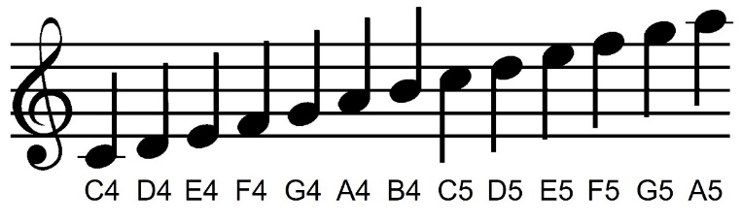
The Treble Clef
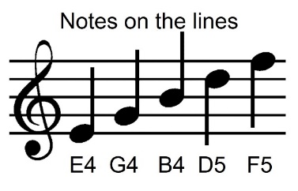
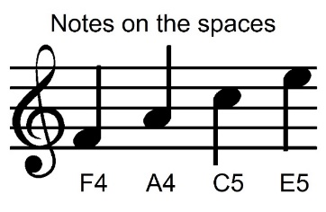
Below is the score for a very popular piece of music - Can you can guess what it is?
Answer: Grande Valse (You may know it as the ‘Nokia Ringtone’)
Did you notice the special # symbols at the start of the score. This indicates that some of the notes are sharps. In this case, the sharp notes are:
F#, C#, and G#
In Micro Python, sharp notes are identified by placing a # symbol after the note, followed by the octave number, for example: “C#4:4”

Below is the music score for the Nokia Ringtone.
Hint: The actual notes are written below the score:
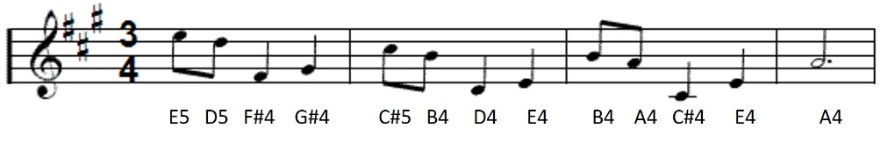

It’s all about the timing
If we look at the notes in a music score again, you will notice that they’re different shapes and colours. These different shapes and colours denote the duration. (See below)
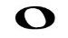 | 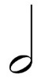 |  | 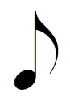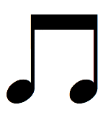
Semibreve  (Whole note) | Minim  (Half note) | Crotchet  (Quarter note) | Quaver  (Eight note)
16 | 8 | 4 | 2
Notice that some of the notes have a dot (or full stop) after them. A dot after a note increases its length by half of its original length, so without the dot, if a note lasts for 2 ticks, adding the dot means it is 2 + 1 = 3 ticks.
 | 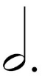 | 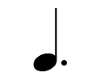 | 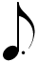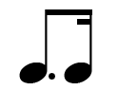
Dotted Semibreve  (Whole note) | Dotted Minim  (Half note) | Dotted Crotchet  (Quarter note) | Dotted Quaver  (Eight note)
24 | 12 | 6 | 3
Below is the score again however, this time, with timings (duration).
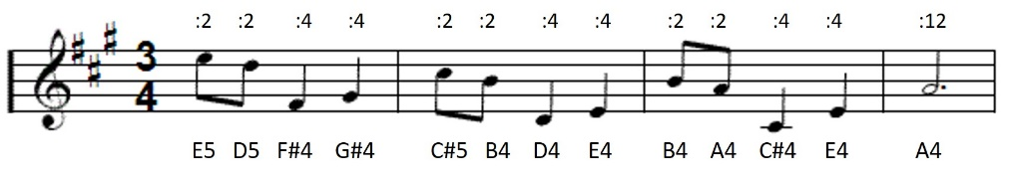
Challenge
- Program your BBC micro:bit to plays the Nokia ringtone.
- Use a loop to repeat the ringtone 4 times (or forever if you want to annoy your teacher!)
- Add code to stop the ringtone when you press button ‘A’.

