Making music with the BBC micro:bit
The built-in music library in TouchDevelop allows us to play music on our BBC micro:bit.
To play a note we use the following command:
Where 440 = frequency (in Hz) and 1000 = duration (in milliseconds).

Playing musical notes
To play a note of a particular pitch, we need to specify the frequency. If we know the frequency of different musical notes, we can translate songs played on a piano to the BBC micro:bit using a table like so:
C | D | E | F | G | A | B
262 | 294 | 330 | 349 | 392 | 440 | 494

Having to find and type in the frequency of each note can be time consuming! Wouldn’t it be much easier if we could just type in the note? Thankfully, with TouchDevelop, you are able to use standard sheet music notation too:
In TouchDevelop, we can also specify the octave number:
Transcribing songs from sheet music
If we want to re-create our favourite songs on our BBC micro:bit, we first need a basic understanding of sheet music.
Here’s a reminder of the most common notes used in a musical score:

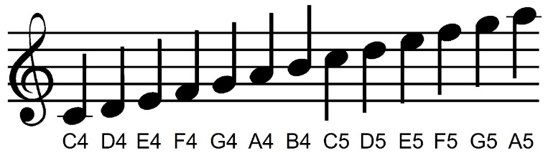
The Treble Clef
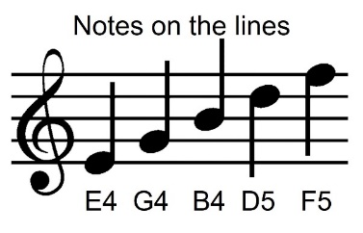
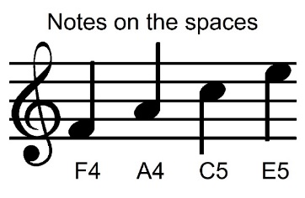
Below is the score for a very popular piece of music - Can you can guess what it is?
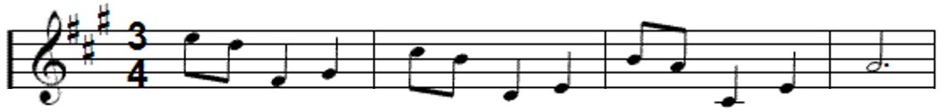
Answer: Grande Valse (You may know it as the ‘Nokia Ringtone’)
Did you notice the special # symbols at the start of the score. This indicates that some of the notes are sharps. In this case, the sharp notes are:
F#, C#, and G#

In TouchDevelop, sharp notes are identified by placing a # symbol after the note, followed by the octave number, for example:

Below is the music score for the Nokia Ringtone.
Hint: The actual notes are written below the score:
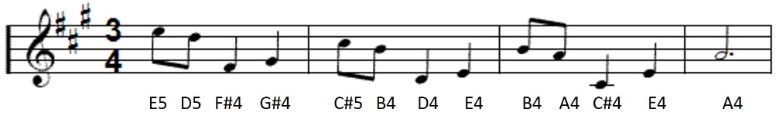

It’s all about the timing
If we look at the notes in a music score again, you will notice that they’re different shapes and colours. These different shapes and colours denote the timings. (See below)

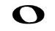 | 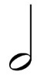 |  | 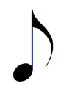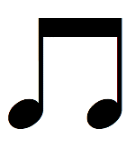
Semibreve  (Whole note) | Minim  (Half note) | Crotchet  (Quarter note) | Quaver  (Eight note)
1000 | 500 | 250 | 125

Notice that some of the notes have a dot (or full stop) after them. For these notes, we need to multiply the duration by 1.5. For example:
 | 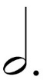 | 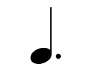 | 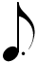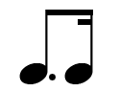
Dotted Semibreve  (Whole note) | Dotted Minim  (Half note) | Dotted Crotchet  (Quarter note) | Dotted Quaver  (Eight note)
1500 | 750 | 375 | 188

Below is the score again however, this time, with timings (duration).
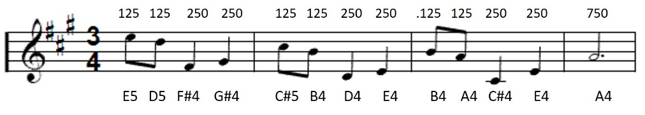
Challenge
- Program your BBC micro:bit to plays the Nokia ringtone.
- Use a loop to repeat the ringtone 4 times (or forever if you want to annoy your teacher!)
- Add code to stop the ringtone when you press button ‘A’.

