BBC micro:bit Christmas Playlist

Silent Night
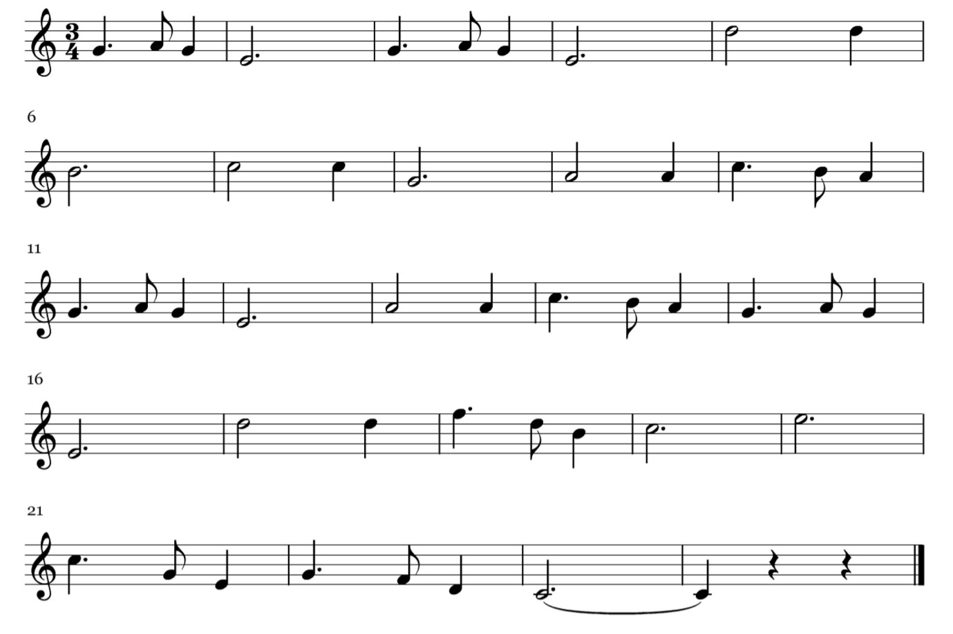

Jingle Bells
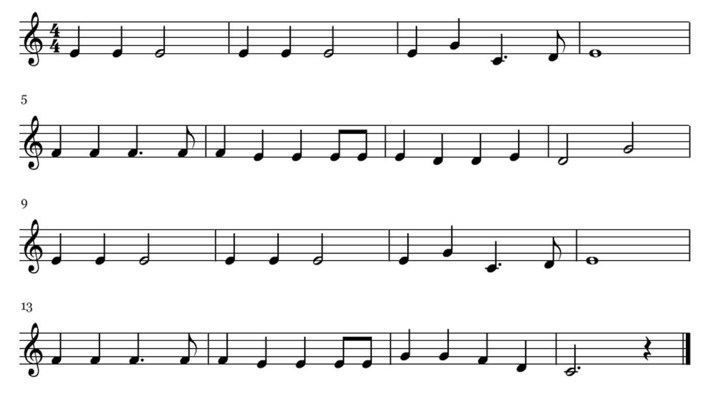

We Wish You a Merry Christmas
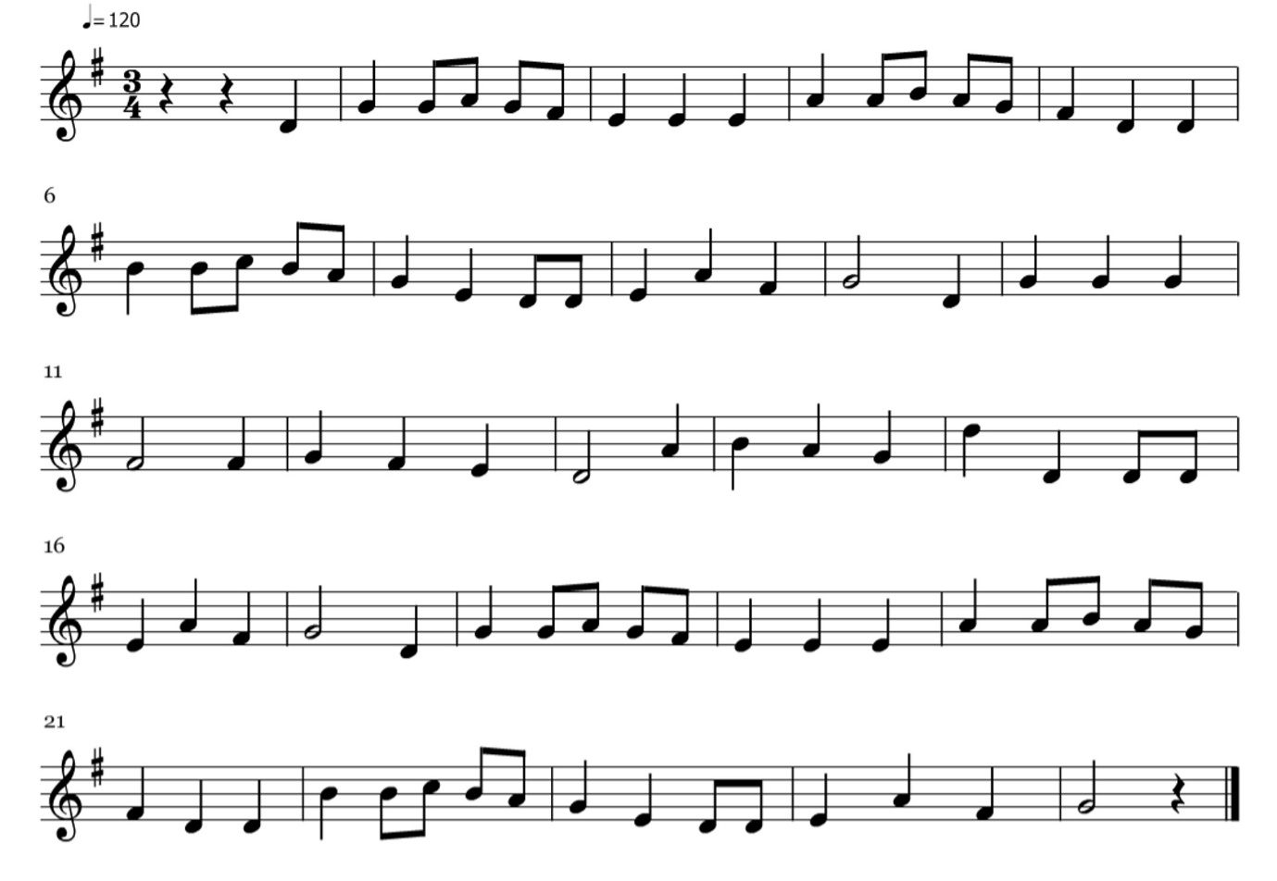
F#

