Medieval Journal
Challenge 20:
Find each of the 20 numbered info blocks and use the table below to make notes.
1 | Un-finished house - 1. Houses were made of a wooden frame, with the gaps filled with woven strips of wood, known as 'wattle', and covered, or 'daubed', with clay and horse-dung. Most roofs were thatch. | 11 | Outside Peasents - 11. The medieval peasant's life was hard & the work back breaking. It followed the seasons, ploughing in autumn, sowing in spring, harvesting in August. Work began at dawn & finished at dusk.
2 | Market entrance - 2. In November the poor would elect a 'lord of misrule', who would wear a paper crown & get up to mischief. At Christmas poor people would go round town demanding traders give them charity. | 12 | Peasant house - 12. Inside the hut, a third of the area was penned off for the animals, which lived in the hut with the family. A fire burned in a hearth in the centre of the hut, so the air was permanently eye-wateringly smoky. Furniture was maybe a couple of stools, a trunk for bedding, and a few cooking pots.
3 | Blacksmith - 3. Medieval shops were workshops, open to the street for customers, with the craftsman's house above. Because few people could read, signs were a huge model showing the craftsman's trade. | 13 | Village Exit - 13. If a serf ran away from his village to a town and remained free for a year and a day, he could become a 'freeman' of the town.
4 | Church - 4. Holy Days would be marked by colourful processions, as the different guilds competed to make the best display. | 14 | Great hall - 14. The great hall would have at least one fireplace with a chimney. This was a Norman invention and stopped the room filling with smoke.
5 | Bell tower - 5. At dusk, a bell rang for curfew, when everyone was supposed to shut up their house. The gates to the town would be closed, and a watch would patrol the streets looking for thieves., and apprentices who had stayed out late. | 15 | Dining hall - 15. Many nobles lived in castles. The great hall was the centre of a castle. The walls were decorated with tapestries. Everyone except the lord sat on benches. There was a minstrel gallery for musicians and singers. At night, the servants slept on the floor.
6 | 6. Villagers had a tendency to empty chamberpots out of their window. | 16 | Dining hall - 16. Many nobles lived in castles. The great hall was the centre of a castle. The walls were decorated with tapestries. Everyone except the lord sat on benches. There was a minstrel gallery for musicians & singers. At night, the servants slept on the floor.
7 | Shop in market - 7. The streets of a medieval town were narrow and busy. They were noisy with church bells & traders calling out their wares. There were many food sellers, selling such things as hot sheep's feet & beef-ribs. | 17 | 17. At the top of the castle, the lady would have a day-room for herself & her maids-in-waiting. This had the largest windows and the best views After 1200, castles had panes of glass in the windows.
8 | Market - 8. A medieval town would seek a charter giving it the right to become a borough. The rich merchants would then be allowed to choose a mayor and hold a market. | 18 | 18. A day in the life of a medieval lord. Dawn: Hear Mass, followed by a breakfast of white bread and wine. white bread and wine. ….
9 | Stocks - 9. Nobody was supposed to carry a weapon or wear a mask. | 19 | 19. The lord had his own room, called the solar, and his own four-poster bed, with curtains for privacy.
10 | Gallows - 10. Criminals were put in the stocks or the pillory. These were wooden boards with holes for feet, hands or head. Crimes such as theft were punished by hanging. | 20 | 20. The toilet, also known as the 'garderobe', was usually a chute straight into the moat. One way to capture a castle was to climb up the chute.

Questions:
Using your notes from the previous task, answer the questions below.

- What is different about the peasant’s house compared to all the other houses in
the village

- What is the significance of the ringing of the church bells?

- What is the ‘Garderobe’?

- What crimes would you be sent to the stocks for?

- What were medieval houses made of?

- How would a ‘Serf’ become a ‘freeman’?
- What did villagers do on Holy Days?
- What is the ‘Lord of missrule’?
- What is the ‘Solar’ and who used it?
- What is a ‘Charter’?

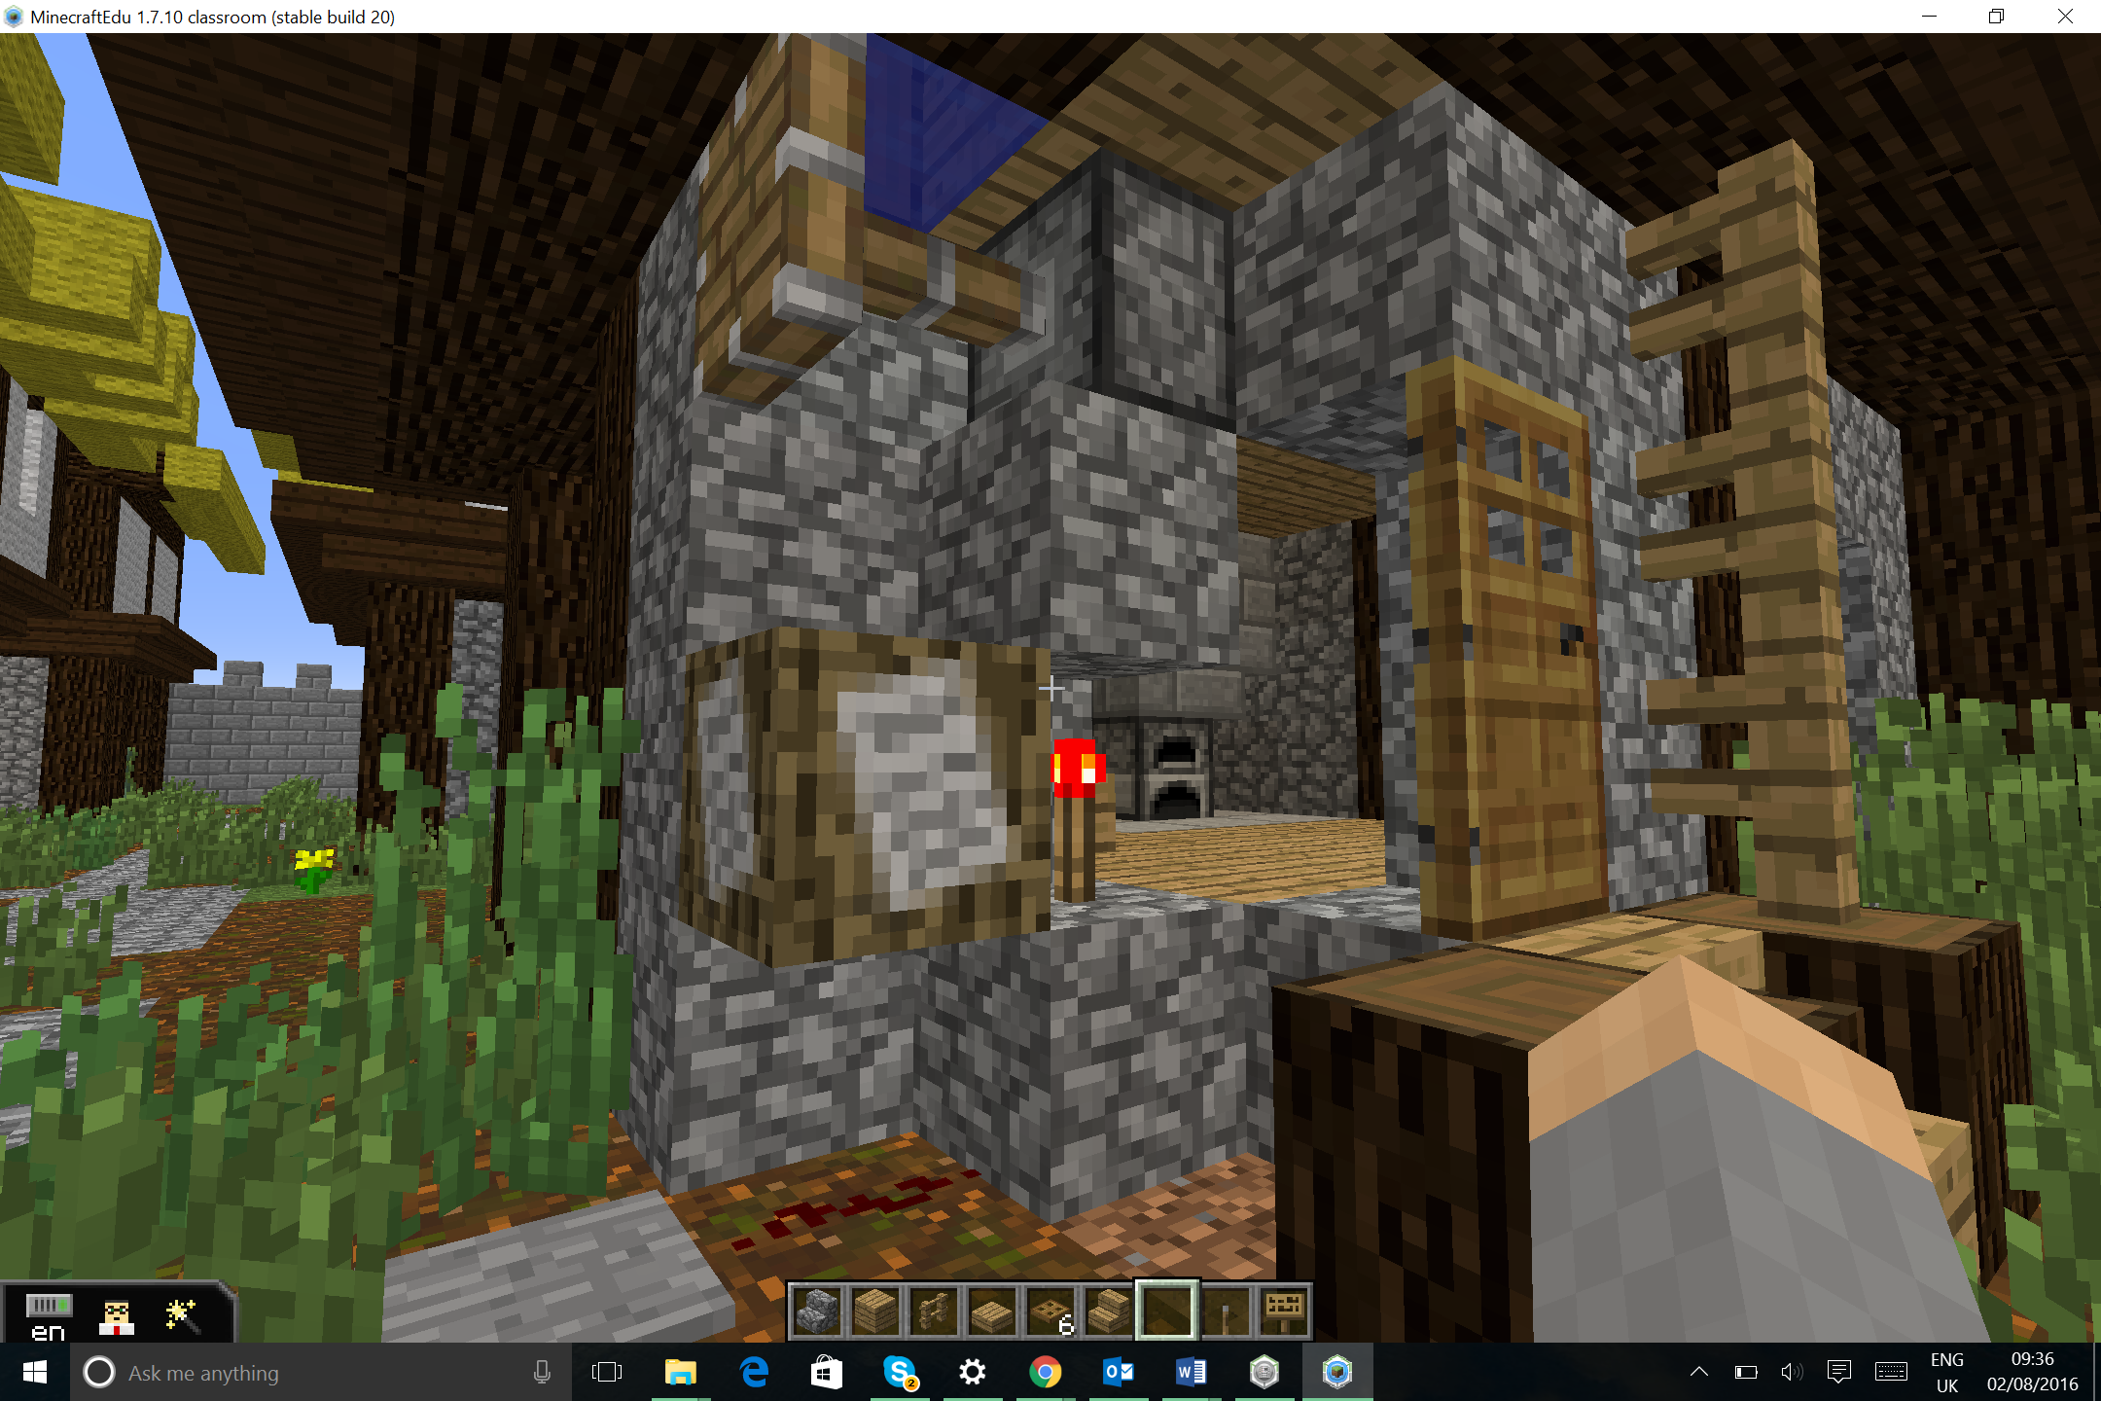

18. A day in the life of a medieval lord. Dawn: Hear Mass, followed by a breakfast of white bread and wine. white bread and wine.
Morning: The lord would speak with his reeve, the general manager for his manor. His lady would perhaps do embroidery. Knights and pages would practise fighting.
10am: Lunch was normally half-a-dozen simple dishes, but if the lord was entertaining guests there would be many more dishes as well as entertainments such as jesters, fools and jugglers.
Afternoon: Hunting or hawking, or chess and backgammon if the weather was bad.
Late afternoon: Prayers, then a meal. If there were guests, this would be magnificent.
After supper: Listen to the news & stories brought by a travelling minstrel, or just sit and talk.
Bedtime: When the lord decided he wished to go to bed, the household would have a light supper, say prayers and go to sleep.

