Making music with the BBC micro:bit – Sheet Music

Frere Jacques/Brother Jon (Beginner)
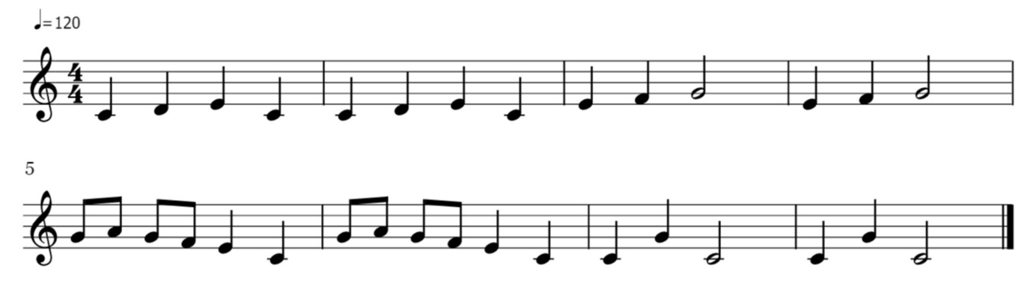
Twinkle Twinkle Little Star (Beginner)
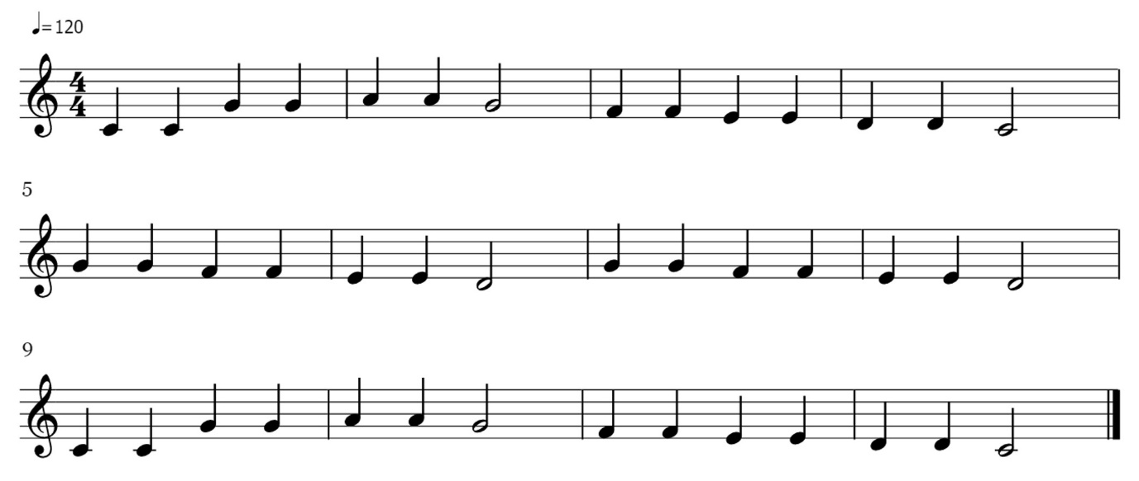
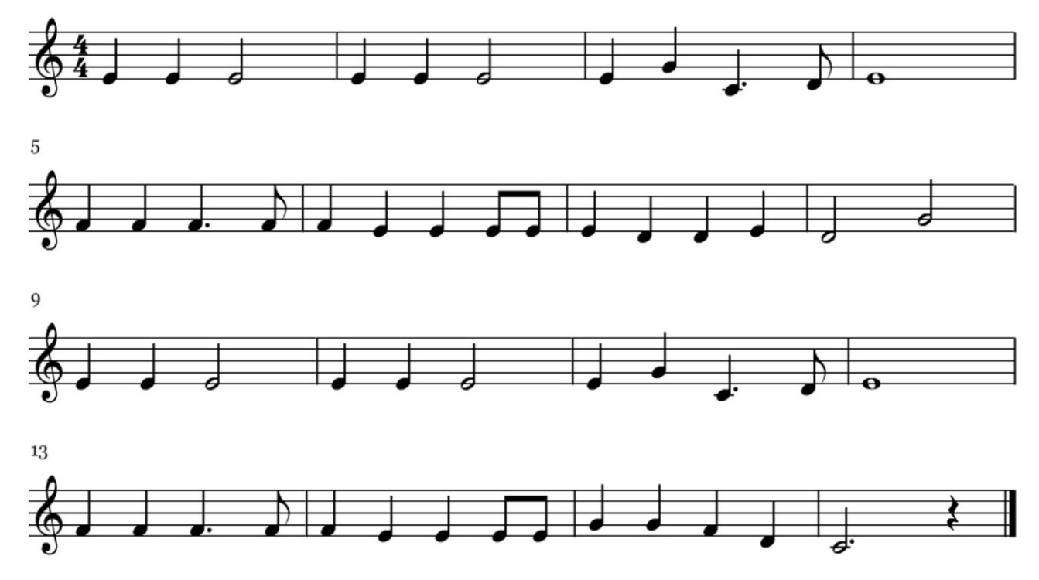
Jingle Bells (Intermediate)

