all in a flap

The rules of the game are simple: the bat can move up and down by tapping the screen; the game is over if you hit an obstacle or fall to the ground. Good luck!

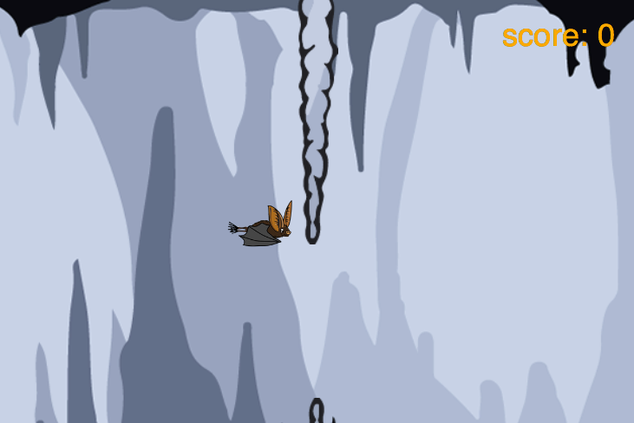

getting started

First you need visit:

https://www.touchdevelop.com/mnhna

If you have a Microsoft account, you will be able to login. You can create an account for yourself or use the app without logging in.

using the tutorial

Click the tutorial button

Follow the instructions step by step. Make sure you read the information that appears between each step so that you gain an understanding of what the code is doing (You will need to write your own instructions later).

remembering instructions

Write the result of each instruction below so that you can use them later when customizing your app:

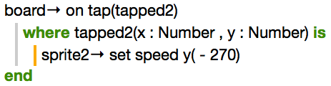
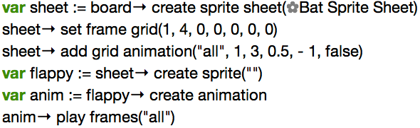

the challenge

Using what you have learnt:

- change the speed of the obstacles to make the game more challenging
- make the obstacles appear closer together to make the game harder
- try using different sprites for the obstacles / character etc.
- add special sprites that provide power-ups such as additional lives

