chat bot

In this tutorial, you will learn how to create a chatting robot (chat bot) designed to confuse the user into thinking that they are talking to a real person.

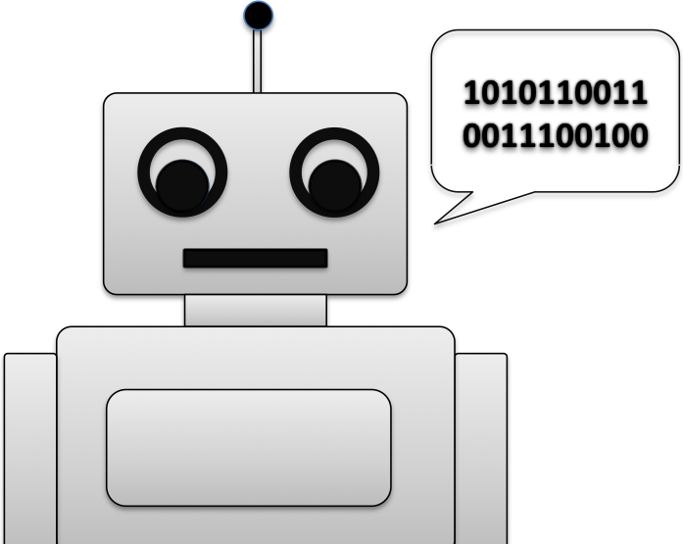

getting started

First you need visit:

https://www.touchdevelop.com/eghl

If you have a Microsoft account, you will be able to login. You can create an account for yourself or use the app without logging in.

using the tutorial

Click the tutorial button

Follow the instructions step by step. Make sure you read the information that appears between each step so that you gain an understanding of what the code is doing (You will need to write your own instructions later).
remembering instructions

Write the result of each instruction below so that you can use them later when customizing your app:

the challenge

Using what you have learnt, create your own chatting robot with your own set of questions and appropriate responses. Suggested improvements:

- There is a problem with our code. The code in TouchDevelop is case sensitive therefore, if you were to type in "Good" (Uppercase g) instead of "good" (Lowercase g) in response to the question "How are you feeling?" TouchDevelop will not find a match and will therefore reply with "I'm sorry to hear that!" In order to get around this problem, we can convert the users reply to lower case using the `to lower case` command.
- At the moment, we only have two responses to the question "How are you feeling?" Add some more responses to make the chat bot appear more realistic. For example: add responses for “I’m fine”, “I’m awesome” etc.

