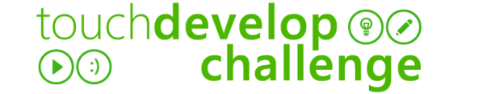

FUNCTIONAL SPECIFICATION

Overview  (What is the name of the app and who are you making it for?) |  | 1
 | Project Manager:  (Your name) | John Smith
 | Client name:  (Name of the teacher you are making the app for) | Mr. Johnson
 | App title:  What is the name of your app? | 3D Dice Roller
 | Deadline:  (When does the app need to be completed?) | December 2013

TARGET AUDIENCE  (Who is the app aimed at?) |  | 2
 | Who is it for? | Who will use the app (teacher / students etc.)
- Gender:
  - Male
  - Female

- Age:
  - Any

- Devices (What devices will the app be used on?):
  - Windows Phone
  - Windows 8 devices (Tablets / PCs)

PURPOSE OF THE APP  (What is the app supposed to do?) |  | 3
 | What will it achieve? | After using this app the user will:
- Be able to:
  - Pick a number at random between 1 and 6
  - Use the app as a virtual dice to use when playing board games

Other:

APP DESCRIPTION |  | 3
 | What must the app be able to do? | The app must be able to do the following:
- Pick a number at random between 1 and 6
- Allow the user to select up to 6 dice
- Display the value of all the dice added together

 | What must the app include? | The app must include the following:
- Navigation (buttons, hyperlinks etc.):
  - Menu button (To take the use back to the main menu)
  - Roll button (To roll the dice)
  - Options button (To allow the user to choose the number of dice)
- Interaction (touchscreen, input, sounds etc.):
  - Work with touch screen devices
  - Work with mouse or keyboard
  - Input screen to allow the user to choose the number of dice
- Colours:
  - Green background
  - Red dice
  - Red menu buttons to match the colour of the dice
- Text (font, size, colour etc.):
  - Title – Arial 16, (white)
  - Other text – Arial 14 (white)

- Images:
  - Dice (One for each face - 1 to 6)
  - Menu buttons

- Sounds and animations:
  - Dice roll sound effect

- Screen size / orientation (e.g. Landscape 800 x 480):
  - Portrait (480 x 800)

Other:

KEY DATES |  | 4
 | What are the key dates? | In order to meet my deadline I must get the following tasks done by the following dates:
 | Main tasks |  | Key date
 | Design |  | Week 1
 | Create assets (Images and Sound) |  | Week 2
 | Create Prototype (To show to the teacher) |  | Week 4
 | Testing and users guide/instructions |  | Week 6
 | Handover to client (Teacher) |  | Week 7

